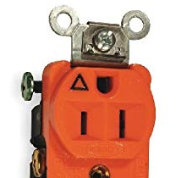ISOLATED POWER LINES

For most computers and registers, an “isolated” power line is often requested.

The power line carries a separate wire for ground that only gets connected to the receptacle.

The metal conduit/MC cable, or a separate ground wire, would be connected to the electrical box.

The receptacle is to have the triangle on the face to show that it is connected as an isolated ground.

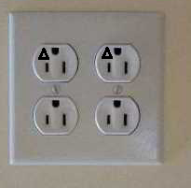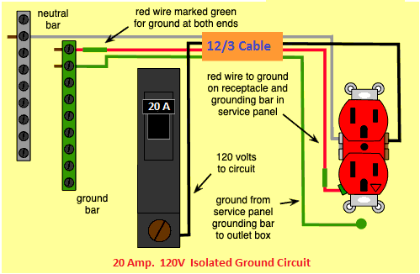

For any work to run a new home run for the computers or phone equipment, the new receptacles are to be with isolated ground indicator. (triangle on face of receptacle)

The receptacles are to be quad ( two duplex receptacles on one circuit)

The above picture is one way. Local codes and the NEC are to be followed and it is up to the licensed electrical installer to perform work based on code.

The installer may prefer to use special MC cable that is rated for a ground.

The breaker is to be marked and the cover plate is to be marked with the circuit number